FIELD REPORT
Introduction
Place: Ngai Seed Secondary School
Location: Ngai, Oyam district
Date of visit: 24th August
- General observations
- The ICT/Library block was not accessible during the verification exercise because the facility had restricted access to the area following a reported theft incident that occurred during the night of 22nd August 2026. As a result, the assets within the ICT/Library block could not be physically inspected or verified against the available records. This limited the completeness of the asset verification exercise.
- There were also inconsistencies in the information provided regarding the assets reportedly stolen. The DEO indicated that 16 computers had been stolen, while the deputy headteacher reported that 16 CPUs had been stolen. The discrepancy in the descriptions made it difficult to establish the exact nature and number of assets affected.
- Since the area remained inaccessible, it was not possible to independently confirm the reported loss, determine the specific assets affected, or establish whether any other UGIFT-supported assets remained in the block.
2. Special notes
- The verification of ICT/Library assets remains incomplete due to restricted access to the block with the differing accounts regarding the stolen items reconciled using the school's inventory records, delivery documentation, and/or other relevant asset records from the district. The reported theft should be treated as a matter requiring further investigation and documentation before the status of the affected assets can be conclusively established.
- All assets are not engraved
The table below illustrates some physical status of the verified assets with photographic evidence.
Table XXX: Physical verification photos
TYPICAL SET OF STAFF QUARTER’S BLOCK  (HOUSE BLOCK WITH TWO UNITS, KITCHEN AND TWO STANCE TOILET BLOCK) | 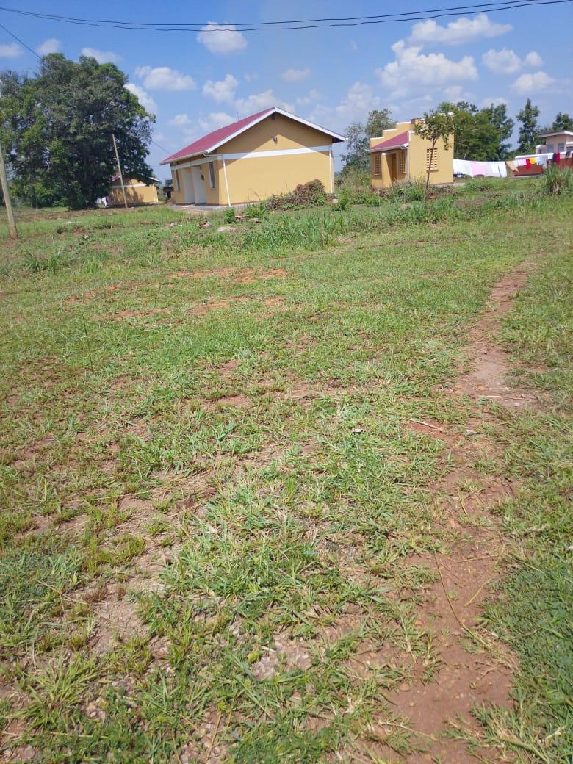
TYPICAL SET OF STAFF QUARTER’S BLOCK  (HOUSE BLOCK WITH TWO UNITS, KITCHEN AND TWO STANCE TOILET BLOCK) | 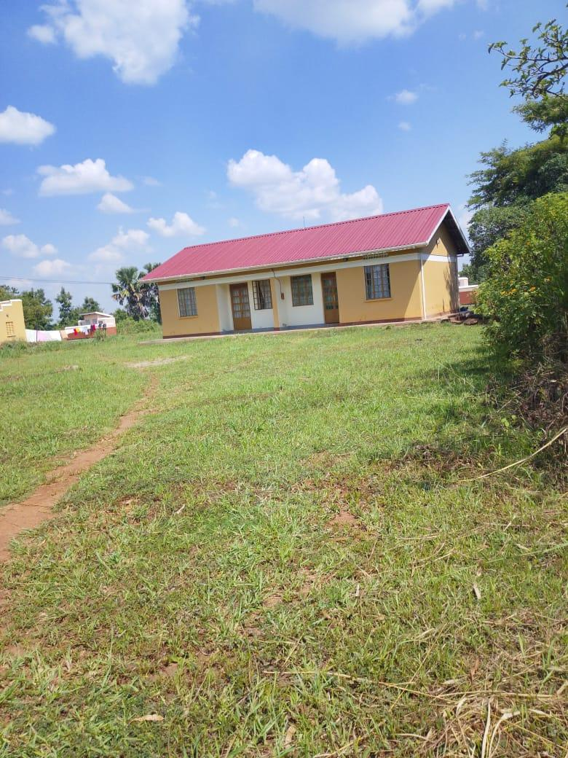
STAFF QUARTER’S BLOCK  (TWO STANCE TOILET BLOCK) | 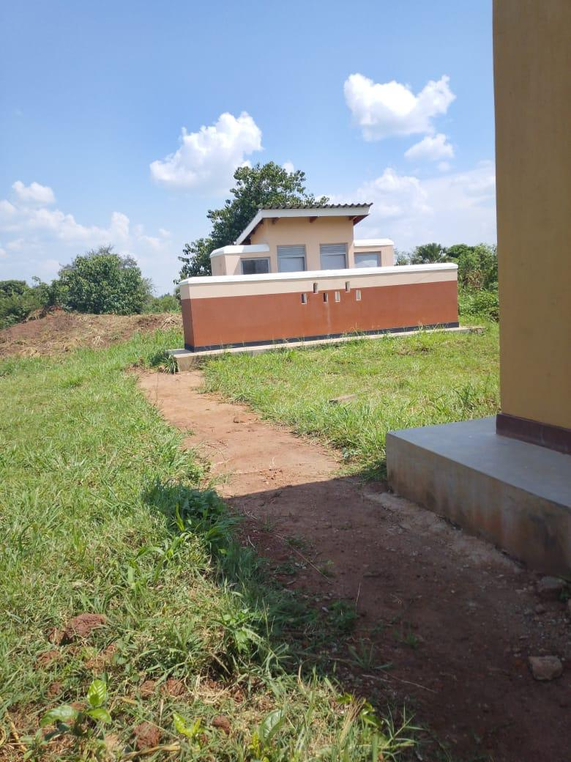
SCIENCE LABOLATORY BLOCK WITH TWO UNITS | 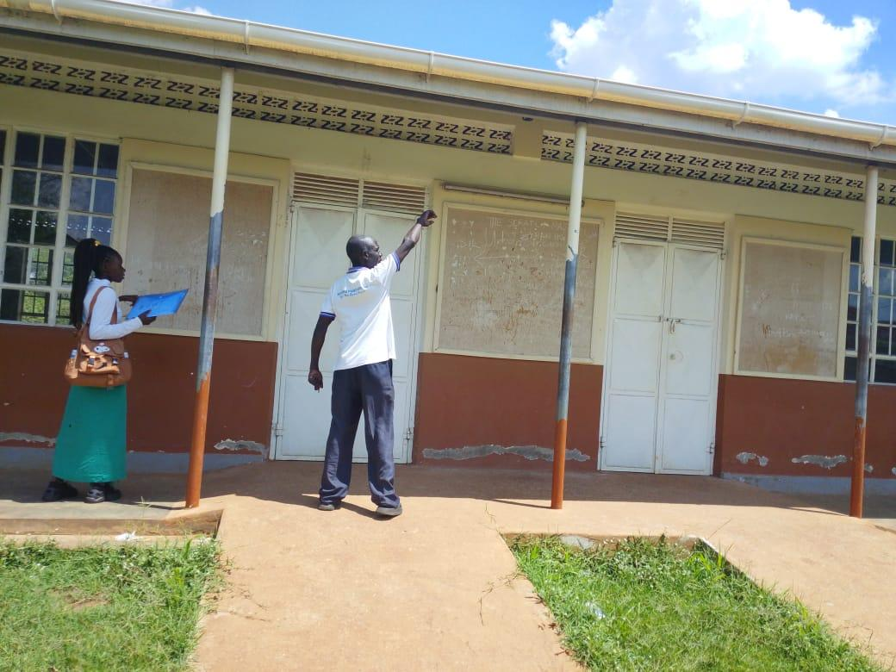
ADMINISTRATION BLOCK WITH TWO UNITS | 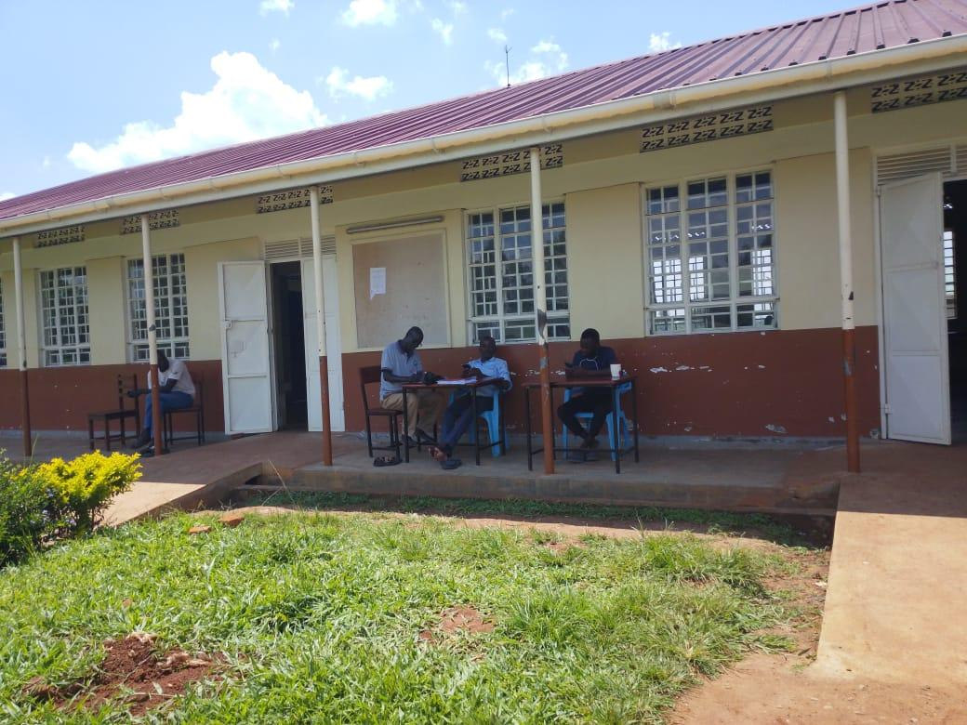
ICT /LIBRARY BLOCK | 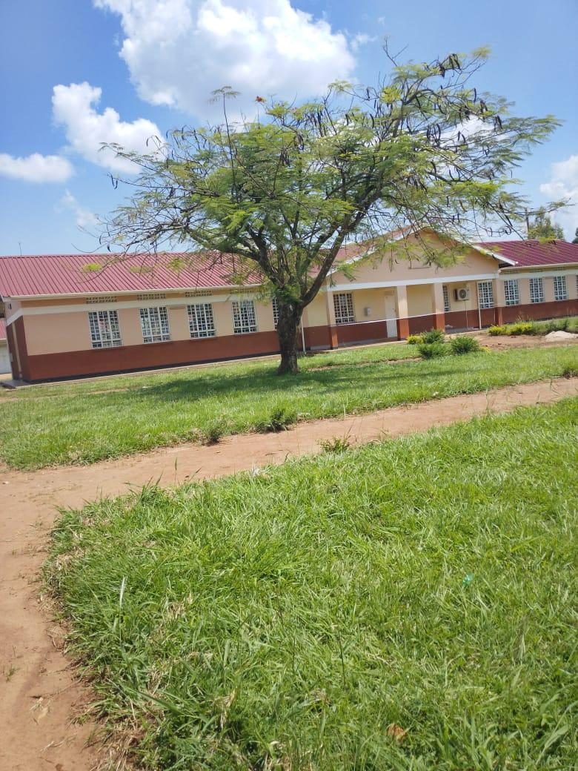
3,00OLTRS ELEVATED HDPE TANK | 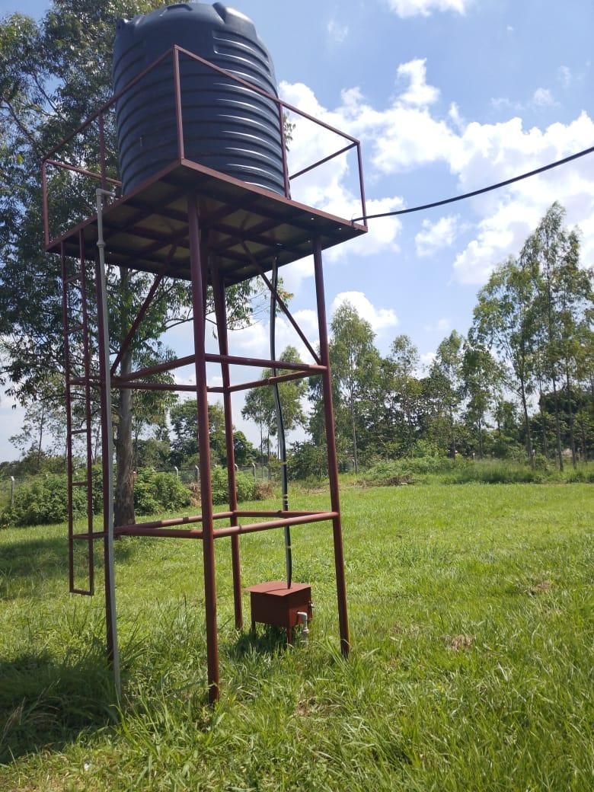
5,000LTRS HDPE CREST TANK WHICH FEEDS A 3,00OLTRS ELEVATED HDPE TANK | 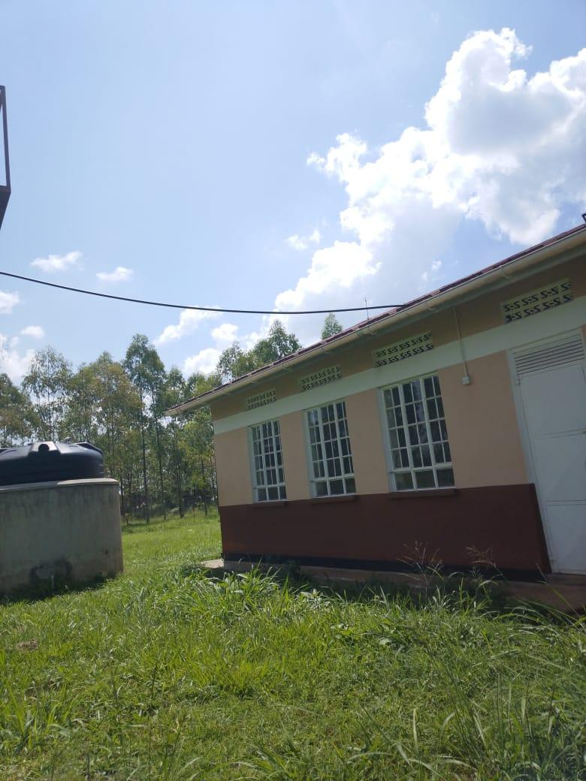
TYPICAL TWO UNITS CLASSROOM BLOCK | 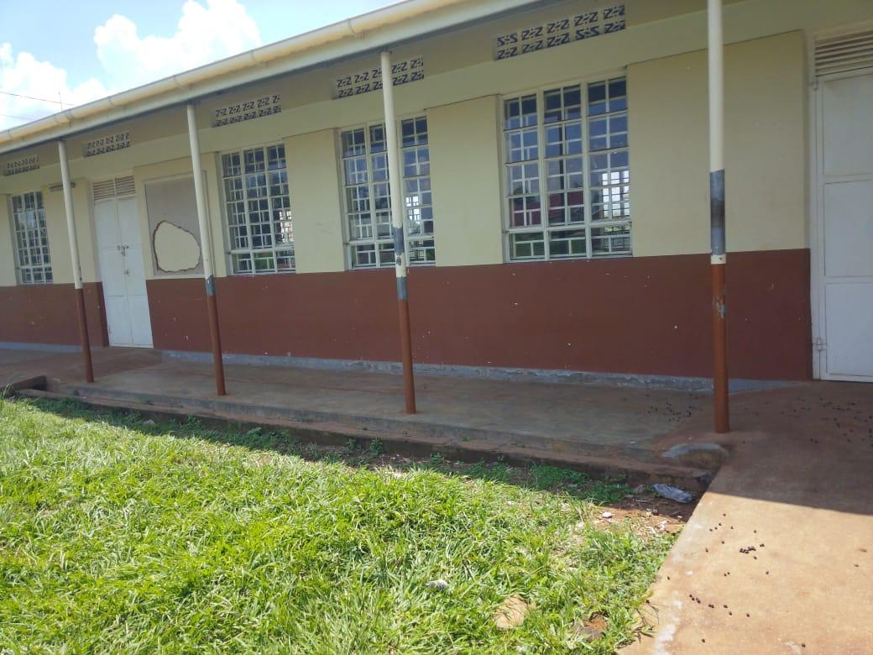
TYPICAL 5 STANCE VIP PIT LATRINE BLOCK | 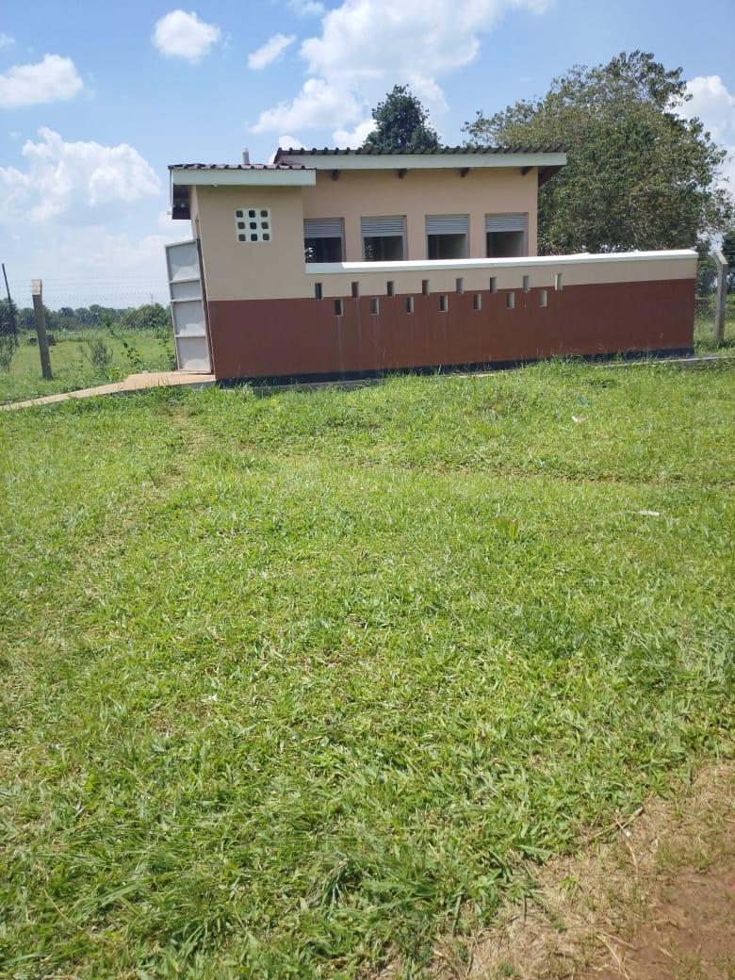
45KG-CYLINDER | 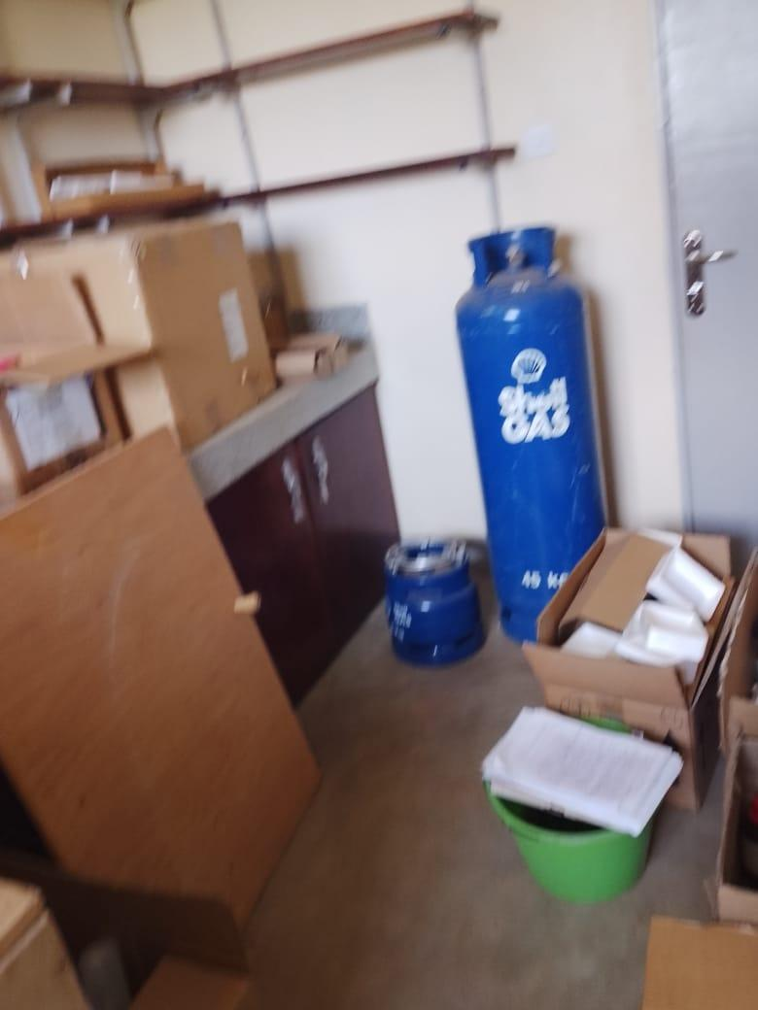
WALL LABORATORY TABLE WITH SHUTTERS, AND SINKS AND WATER CONNECTION | 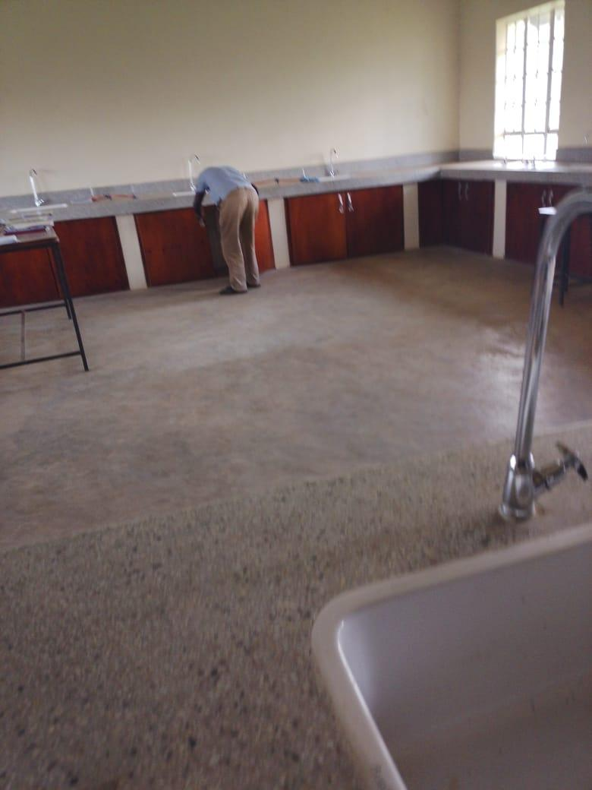
CLASSROOM DESKS | 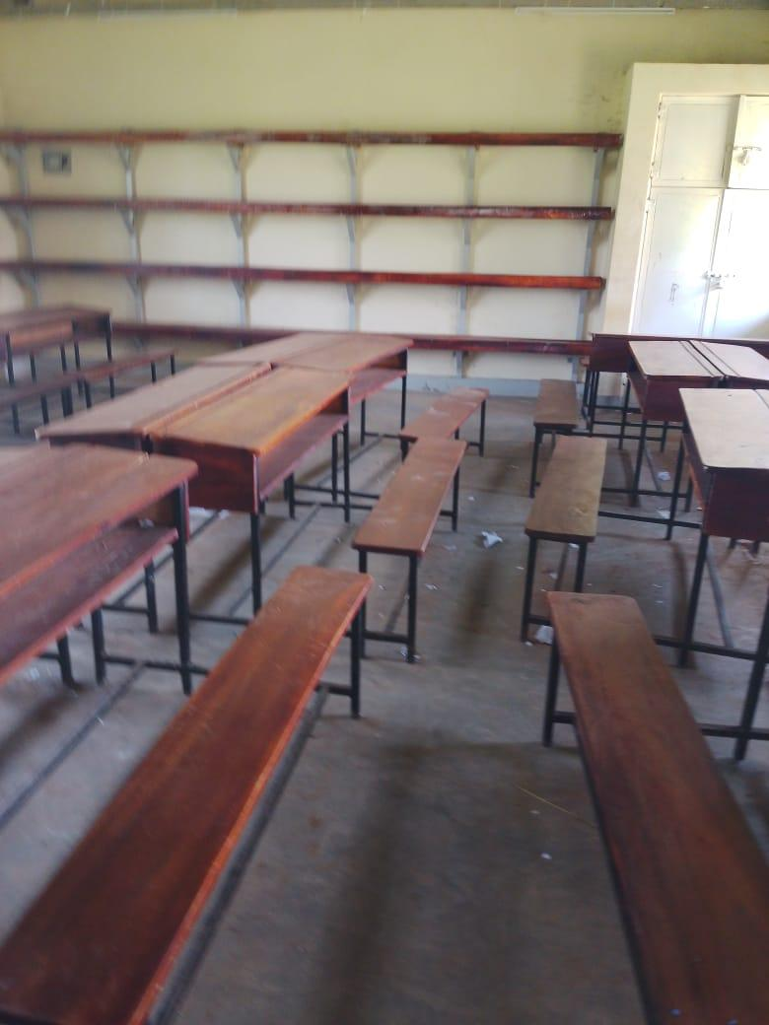
SAMPLE SHELVES AND TABLES | 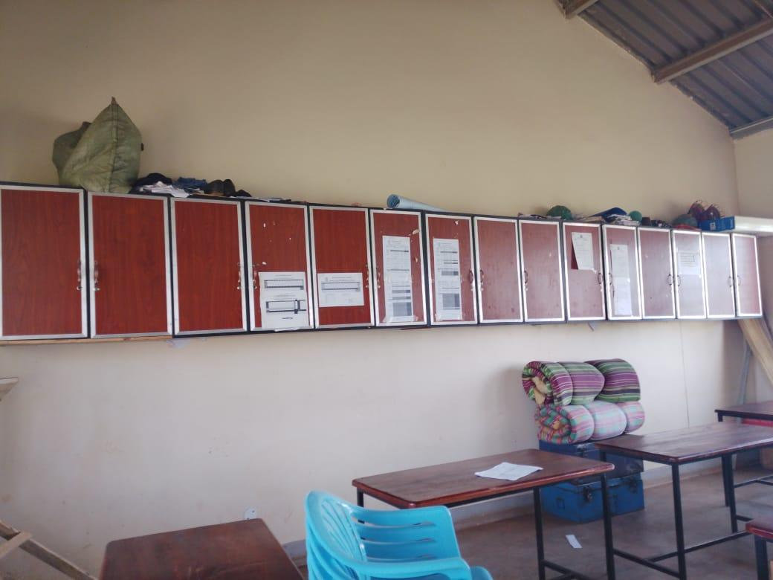
9KG-CO₂ FFIRE EXSTINGUISHERS | 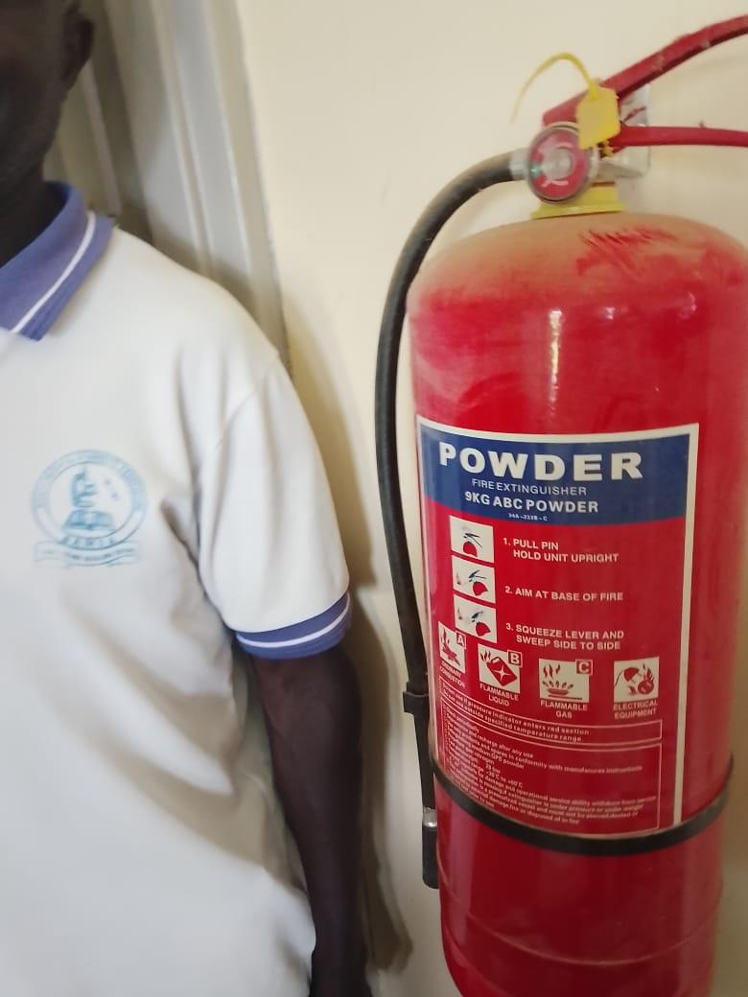
PUBLIC ADDRESS SYSTEM | 